Telegrams: “GUARDIAN” Fax: 091-044- 2524 35 24
Telephone: 2522 07 31
 2522 71 79

(CHENNAI CIRCLE)

(Regd No: 883)
(Affiliated to All India State Bank of India Staff Federation)

Post Box No.1754
STATE BANK BUILDINGS
84, RAJAJI SALAI
CHENNAI – 600 001

CIRCULAR NO.117 4TH MARCH 2013

MARCH ON TO CHENNAI

The 35th General Council of our Union is scheduled to take place on 10th and 11th March 2013 at Kalaignar Arangam, Anna Arivalayam, Teynampet, Chennai. The Reception Committee is making all arrangements to make the Conference a grand success.

Com. Sanjeev K Bandlish, President of our Federation will inaugurate the Conference. Smt. Varsha Purandare, Chief General Manager, State Bank of India, Chennai Circle has kindly consented to be the Chief Guest. Comrade M.V. Murali, General Secretary of our Federation and National Organisation NCBE will deliver the Keynote address. Comrade D.Venugopal Reddy, Former Senior Vice-President, AISBISF and Former General Secretary of our Union, Com. D.S.Rishabadas, General Secretary of AISBOF and AIBOC, Senior Vice-Presidents of our Federation, Com. P.A. Manjunatha and Com. Brajesh Kumar Mishra, Com. J.B.Mohapatra, General Secretary of Bhubaneswar Circle Union and Workmen Director in Central Board of our Bank, Com. Thomas Franco, General Secretary, SBIOA (Chennai Circle) and Com. P.P.S.Murthy, General Secretary of Federation of Pensioners’ Association will also participate as Special Guests and deliver their address on issues concerning Bank Employees. The Presidents and General Secretaries of all affiliates of our Federation will also be participating in the Inaugural Session of the Conference.

The invitation for the Inaugural session of the 35th General Council and the Conference Guide containing information regarding the Location of Kalyana Mandapams where the lodging arrangements have been made for all Delegates/Observers coming from Branches outside Chennai, location of the Conference Venue etc. have already been despatched to all the Units.

The Reception Committee headed by Com. S.M. Selvaraj, Vice-President (Head Quarters) of our Union is working round the clock with the team of Volunteers for the conduct of the General Council in a grand manner, befitting the stature of our great edifice.

The Inaugural Session will commence at 9.30 a.m. on 10th March 2013. On that day, it is also proposed to organize a “Blood Donation Camp” from 9.00 a.m. We request our Members to donate blood which is a noble act. The Donors may contact the Reception Committee members for the purpose. It is also proposed to commence the Delegate Session at 4.15 p.m. We request all our Members to participate in the meeting and extend their whole-hearted co-operation to maintain the time schedule.

We are confident that this General Council will be a memorable one symbolizing our unity and solidarity.

March on to Chennai Comrades! Make our 35th General Council a grand success and historic one !
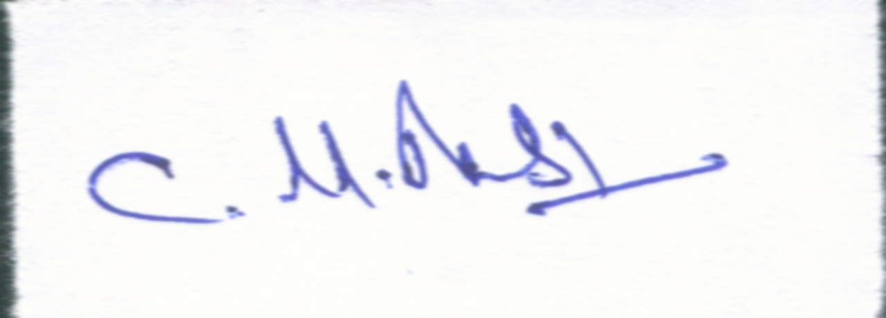

(C.M.BASKARAN)
GENERAL SECRETARY

S B S U (C C) ::: A I S B I S F ::: N C B E ….. ZINDABAD

